SpaceX Starlink: Internet for the Masses
SpaceX recently came crashing onto headlines with yet another test flight crash of the Starship 9. Nevertheless, SpaceX has recently found success in a different arena: satellites. SpaceX recently successfully launched thousands of satellites into space, for their new Starlink internet service. They now own approximately a third of all active satellites in the sky (1). As one might imagine from SpaceX, this move is both controversial and game changing.
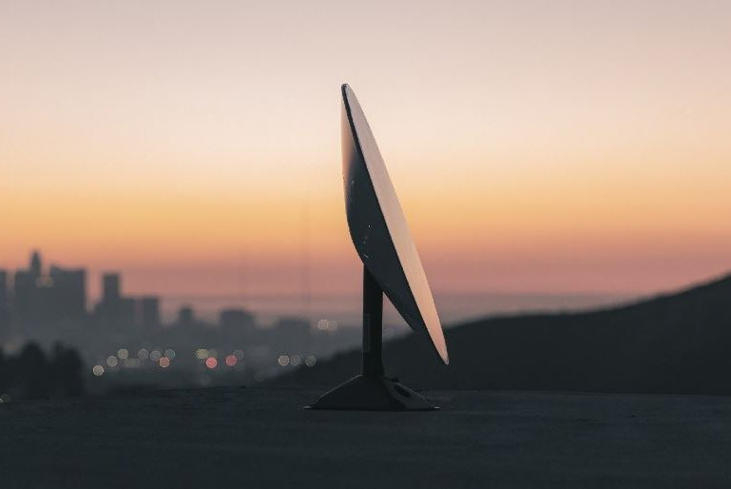
SpaceX plans to boost Starlink network with launch - UPI.com
SpaceX’s satellite web consists of 1,000 satellites orbiting 340 miles above the Earth, with the plan of eventually reaching 40,000 satellites (1). The objective of the satellite service is to beam cheap, highspeed internet to rural areas, where internet is often spotty or limited. Already, they have 10,000 customers (1). Already, it has proven a success among those that use it. At a price tag of $99 a month, users have reported that the service is significantly better than most local offerings. Elon Musk, SpaceX’s CEO, has projected the service to provide $30 billion a year for the company. This would be ten times more than their usual rocketry revenue streams — a major source of funding for their ultimate missions to Mars.
While the future of Starlink looks bright, its bright future may also pose a problem. Many astronomers have expressed concerns of light pollution from the satellites (1). Satellites have already interfered with several telescope images, requiring astronomers to do more work when parsing through their data. Furthermore, there are increased fears of collisions with space debris. SpaceX has attempted to address these concerns by keeping their satellites in low orbit and using sun visors (1). Though, it is likely that ground based observatories are on their way out due to these shifts.
On top of space concerns, there are economic concerns. While Starlink is only $99 monthly, it requires a $499 deposit for the compatible equipment (2). Additionally, SpaceX had to take out massive loans to fund this project (2). Starlink is also facing competition from many other services. Blue Origin plans to start a satellite network known as Kuiper, and there are also the networks of OneWeb and Telesat (2). Elon Musk himself has even acknowledged the ambitiousness on the project. Specifically, he had this to say: “Every new satellite constellation in history has gone bankrupt. We hope to be the first that does not” (3).
Considering the track record of SpaceX, it is safe to assume that this service is in position to be yet another massive win for the company. Risky as many of their moves are, they always are moving toward the future. There is high probability that satellite networks like Starlink are on their way to becoming a standard usage throughout the world’s rural communities.
Sources:
- Elon Musk's SpaceX now owns about a third of all active satellites in the sky - CNN
- SpaceX plans to boost Starlink network with launch - UPI.com
- SpaceX begins accepting $99 preorders for its Starlink satellite internet service as Musk eyes IPO (msn.com)

